

Corporate valuation project

*Simone Luca Lucchesi, Gianmarco Cavaliere*

**A Little Brief Of A2A History, Values and Missions**

A2A S.p.A is a public traded firm at the top of Italian multi-utility companies, listed on Borsa Italiana and component of FTSE MIB index.   
It was born in 2008 from the union of three Italian companies (AEM S.p.A, ASM S.p.A, and AMSA) that had operated in the same sector and same geographical area.

The group is well-known in local utility reality, first of all in Italy, especially in Lombardia where it is based. It hasn’t an international network but it has started to expand its horizons in the European contest establishing technology partnerships in United Kindom, Spain, and Greece. From 2009 A2A has been operating, after the acquisition of EPCG, also in Montenegro.

Whit more than 12000 employers, A2A is a leader in production, distribution, and sale of energy, distribution and sale of methane gas, production, and sale of district-heating.   
Their production process is oriented above all to a green-view and on a circulatory economy; indeed this company obtains 80% of the energy generated using clean sources.   
The energy is generated using a lot of different technologies, that vary from hydropower to solar power, and systems like cogeneration and thermoelectric plants. But, as mentioned above, A2A is a multiutility, in fact in addition to production and distribution of energy, it is engaged in urban hygiene (so waste disposal and street cleaning), public lighting, developing smart and sustainable cities.

As you can well understand the first ethical value of this company is **sustainability**, not only a value but also an aim.   
Sustainability reached through reducing at the minimum level the *environmental impact* generated by energy production, enhancement of the territory and also exploiting the circular economy.   
Although this is one of the principal values of a firm it is not the only one.   
Indeed, A2A believes strongly in *technology innovation* improving constantly investments in R & D and the quality of the plants.   
Another one is *participation*, focusing on customers ' feedback and a great sense of responsibility to customers offering all types of energy available.

The company counts a large number of costumers, in particular, one million for electric energy, more than one million for natural gas, and around three hundred thousand for hydropower.

**More Details About A2a Mission**

As announced **Sustainability** is the core aspect of the company and its management: a little proof is given by the approved strategic plan which covers the period from 2019 to 2023.   
But not only, enven A2A business plan is a reconfirmation of its aim.

A2A’s management thinks that the key to a sustainable growth for the company is given by a weighted use of six different capitals:   
Financial, Manufacturing, Natural, Human, Intellectual, and Relational. From that, we can catch that A2A is not only profit oriented but also focused on people, whoevere they are, workers or customers.   
Indeed, A2A’ve decided to engage in order to achieve the SDGs, a lot of which were provided by ONU.



The industrial model is centred on three different words which also represent the framework of the company:

* Transformation
* Excellence
* Community

These words are connected all together with three main macro-industrial trends that the company wants to follow and pursue.  
One of them is the *circular economy*: intending to handle sources during their whole life cycle is a sustainable way. With the circular economy, A2A is trying to pursue three different goals: *clean water, and sanitation (6),* *responsible consumption and production (12)* and *life on land (15)*, through:

* Landfill phase-out.
* Acceleration in sorted collection.
* Waste system balance and material recovery.

These objectives reflect A2A desire of becoming a national leader in material recovery doing more investments to accelerate thermal plant reconversion. All with a circular economy perspective designed according to local needs making them “greener” and to improve the production cycle.   
Not only, another goal in this context is a Vertical integration downstream improvement in order to sell secondary raw materials, focusing on plastic/ paper and at the end entering in B2B environmental services, and partnership in hazardous waste.   
These are tangible examples of transformation.

The second trend is the *energy transition*, through which A2A is pursing following goals: *affordable and clean energy (7)* and *climate action (13)*. These two aims are tried to be reached through:

* Decarbonization
* Energy democracy
* Reduction of photovoltaic (PV) and wind Levelized cost of energy (LCOE)

Energy democracy and decarbonization, of district heating and plants, are really important concepts through which A2A is trying to make people more sensitive, to sustainability theme in general and in particular on the emissions theme.   
An example is given by the fact that A2A offers different types of energy to each client thinking that everyone must have guaranteed access to the energy they need and reducing the LCOE of green energy could be a clever strategy to push people to pass on the green side.

With the last, but not least, trend A2A want to catch two goals: *industries innovation and infrastructure (9)* and *sustainable cities and communities (11)*. It wants to offer smart solutions providing:

* Green mobility
* Smart services to inhabitants and digitalization (IoT)
* Energy efficiency

A2A, in fact, is engaged in the project “E-moving” for citizens and territories. This project aims to make more feasible and accessible the use of electric vehicles because of the strong beliefs that the future of mobility is “electric”. Concept linked to decarbonization for CO2 emission reduction.

Beyond that, one of the biggest projects of A2A is the “Smart City”: a project which wants to allow for an improvement of economic efficiency and social, cultural, and urban development.   
This thanks to a combined use of available resources and through a proper management of enabling technological infrastructures for integrated and networked digital services.

The company, as seen above, is characterized by its customer focus, and exactly for this reason it is trying to give the best service possible, aiming to excellence. In fact, through digitalization A2A wants to create digital users offering also an Outstanding client service with multi-channel customer experience.

For what concern Energy efficiency, the company wants to strongly improve EPC projects with significant investments.

Finally, A2A believes in people. Indeed, the company imposes itself further goals to actively contribute to people innovation, accordingly to *quality education (4)* and decent work and economic growth, offering to their employees high standards of health and safety, training initiatives, benefits, and welfare programs. But also they are following the aim of *gender equality (5)* stating that by 2023 20% of managerial positions will be covered by women (+50% concerning 2018).

**Economic Targets**

The last part of the strategic plan is dedicated to financials.  
A2A has declared targets for EBITDA, Net Income, Capex, NPF over EBITDA and Dividend:

* *EBITDA*: A2A stated a compounded annual growth rate equal to +6,4%, which pumps up EBITDA from 1192 in 2019 to 1626 in 2024.

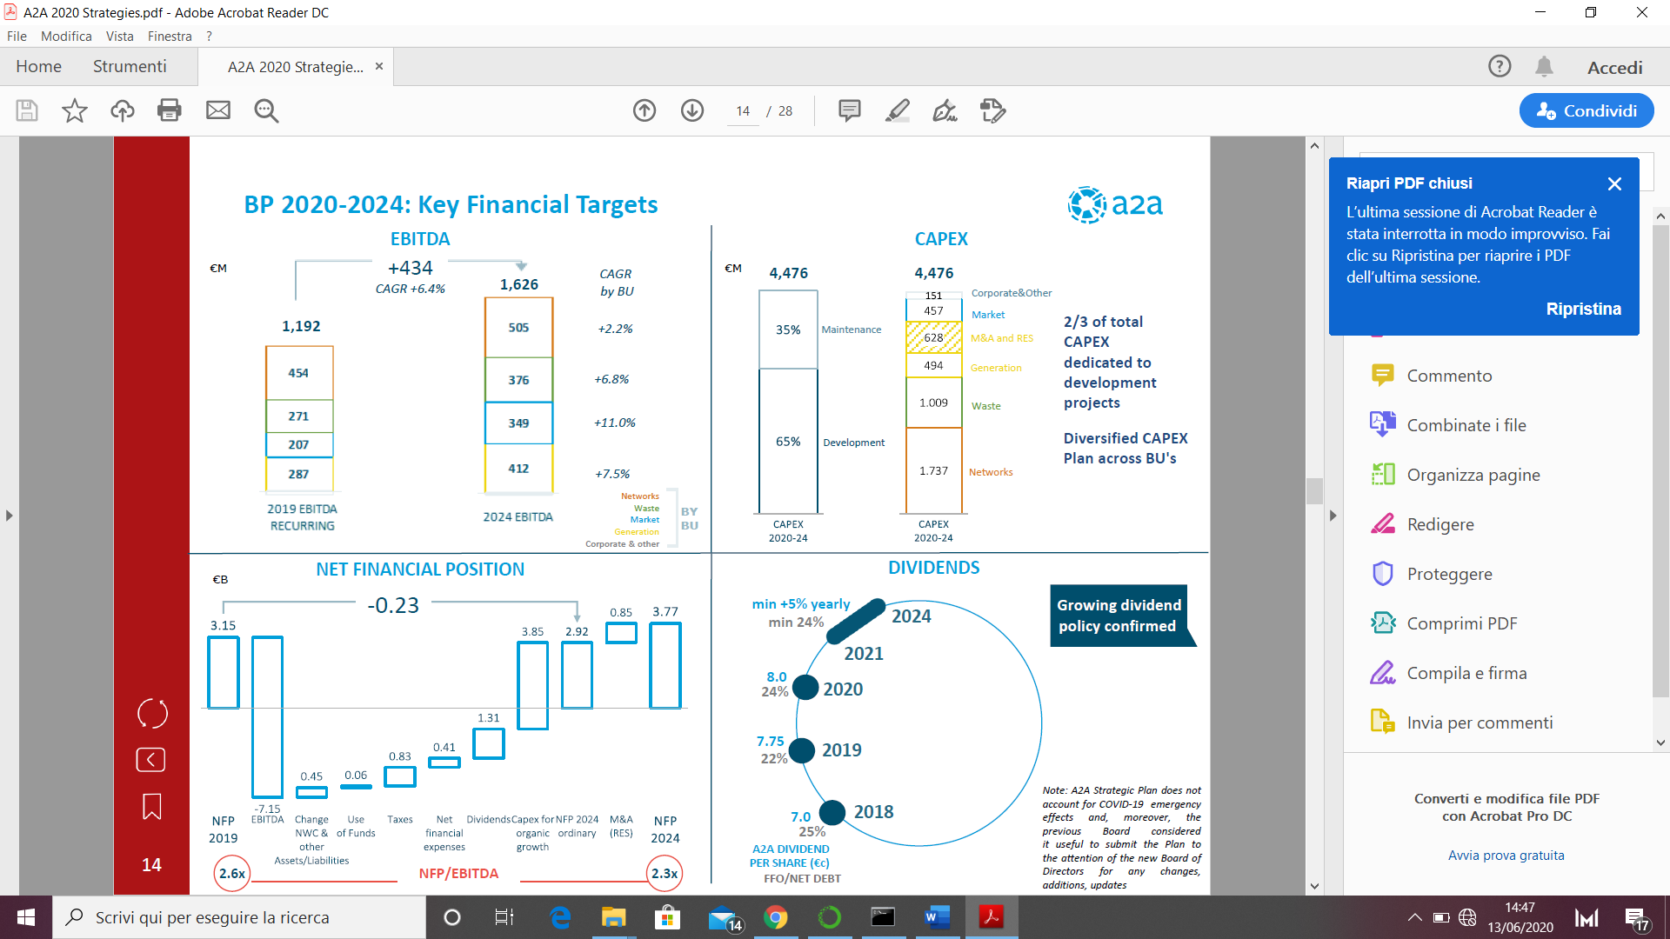

* *Net Income*: for this value we rely on previous year strategic plan.The company declared an increase more or less of 35% (from 344 to 462) with a CAGR of +6.1%.

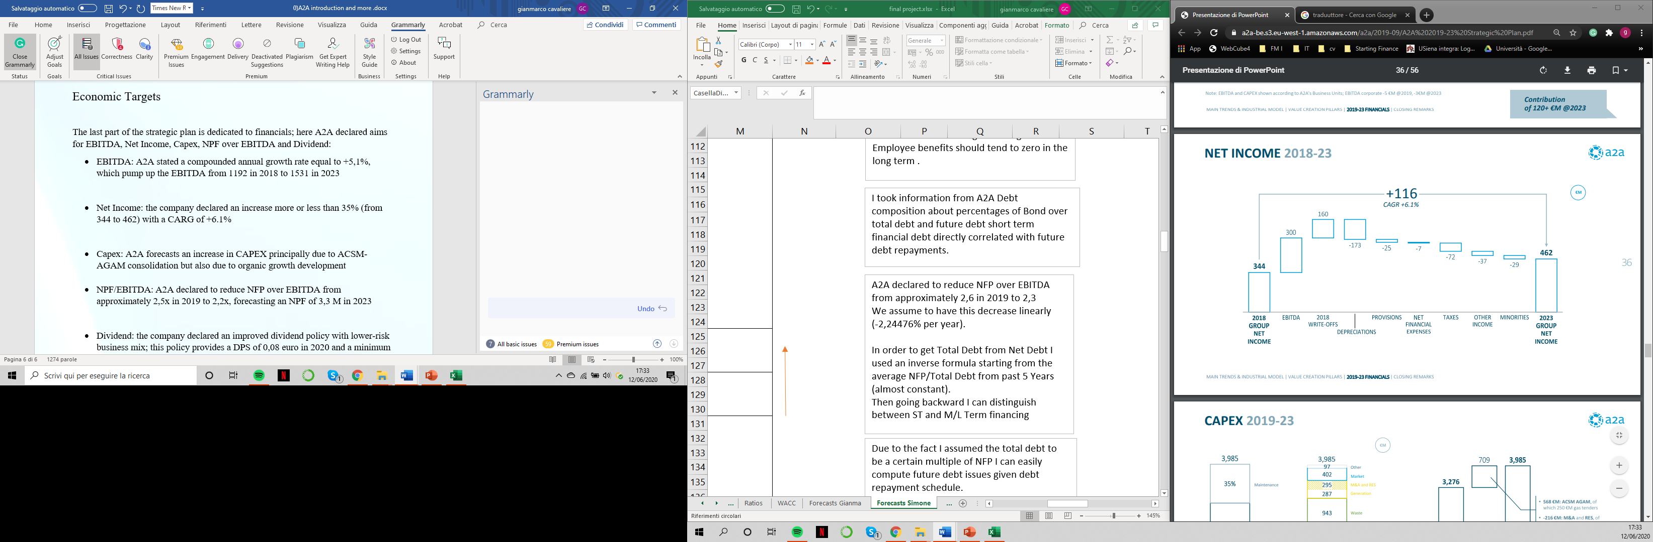

* *Capex*: A2A forecasts a cumulative CAPEX for next years of 4,476 billions, principally due to ACSM-AGAM consolidation but also due to organic growth development.



* *NFP/EBITDA:* A2A declared to reduce NFP over EBITDA from approximately 2,6x in 2019 to 2,3x, forecasting an NFP of 3,77 M in 2024.



* *Dividend policy*: the company declared an improved dividend policy with lower-risk business mix. This policy provides a DPS of 0,08 euro in 2020 and a minimum bound of growth, at least, +5% yearly.



**Sources: A2A’s investor plan 2020-2024; A2A’s strategic plan 2019-2023**

**Reorganized Financial Statements**

***Sources***

* A2A’s disclosures since 2015: consolidated financial statements, future target reports.
* A2A’s first quarter relations since 2015 until 2020, this in order to compute LTM statements.

***Our workaround***

First, we have downloaded balance sheets and income statements (or P&L) from consolidated financial statements, we organized two excel sheets filled with all the details.

Then, we have created a sheet with the purpose of representing all restatements including a proper cash flows statement. The latter was structured to highlight NOPAT, Net Capex, changes in Net Working Capital, FCFF, FCFE, and equity movements.

All in order to reconcile cash flow changes with bottom line of our prospect called NCF (net cash flow).

**Overview representation of all statements**

 *Balance sheet (comment)*

*Financials*: composed by shareholdings and non-current financial asset.  
   
*Operating working capital:* includes only inventories, trade receivables and payables.

*Other assets and liabilities* such as other non-current financial assets or tax liabilities were all included in residual part, in order to get net working capital.

*Residual items*: net deferred taxes, provisions for risks and employees’ benefits.

Summing all we got what we called *Net Invested Capital* (denominator for ROIC).

*Equity* was maintained equal to reported whereas Debt included only financial liabilities (Long Term and short term).

Netting out cash and cash equivalents we obtained *Net Debt* (NFP).

Finally, sum of equity and Net Debt, called *Total capital employed* must reconcile with NIC.

*Income statement (comment)*

**  
  
  
  
  
  
  
  
  
  
  
  
  
  
  
  
  
  
  
  
  
  
  
  
  
  
  
  
  
  
  
*Revenues* include both operating revenues (sales) and other operating revenues.

*Operating costs* include materials, services and other operating expenses.

*Financial items* represent the net value obtained summing results from non-recurring transactions and financial balance.

*Residual items* are the same presented in consolidated income statement. In our analysis we used as NPL (Net Income) group result of the year.

*Cash flow statement (comment)*

In cash flow reorganization we started from EBIT, we subtracted reported taxes and an additional item called *Shield on financial items*. This represent the additional taxes paid on a full equity firm.

The sum yields to what we called *Nopat*.



Then, we highlighted changes during the years of *NWC* (and *WC*): we considered with positive sign negative changes, this because the contribute in terms of cash is positive and viceversa.

We obtained what we called *Net Capex* considering changes in tangibles and intangibles in years and adding current D&A. As we can see their contributes are always negative: there were increases every year which reduced cash flow.

Then, D&A was subtracted, non-cash cost which would have been counted two times otherwise.

What we called ∆ [“something”] represents changes in other residual items: with positive impact to cash if decreased and viceversa.

For *other minor* we have considered two items in income statement: minorities and net result from discontinued operations.

Summing *Nopat* with *∆ NWC* and other items we got *Free Cash Flow to firm*.

Then, we subtracted financial items which were enlarged also by changes in financial fixed asset for each year, we considered changes in total debt (positive sign if issues were higher than repayments) and re-added previous shield on financial items in order to get *Free Cash Flow to equity*.

Finally, from FCFE we subtracted *equity movements* obtained by subtracting NI from changes in equity for each year.   
This operation yields to what we called Net Cash Flow (NCF) which must be equal to changes in cash balances during the year (End value – Begin value).

***Trailing 12 months***For knowledge purposes we performed also the reorganization according to trailing 12 months approach.

We obtained most recent values for Balance Sheet Items from Quarterly reports.

For what about P&L we computed LTM according to the following formula: each item would be equal to

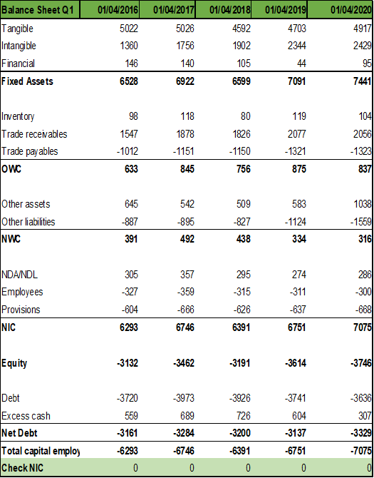For what about cash flows we rearranged in the same way results from BS and P&L. Of course, restatements were made using same syntax and way of grouping.





All presented results allow us to get more updated information.

Anyway, for consistency reasons we did not used in our valuation analysis, this because in computational procedures we considered data time series until 31/12/2019.

**Comments**

It’s interesting to notice the Covid19 effect in LTM Income statement: revenues reported are slightly lower. This comes from the fact that reported values in Q1 2020 were lower than Q1 2019 reducing values in consolidated report for 2019.

Anyway, in terms of EBITDA and EBIT this was diluted by drop in operational expenses: operational results are slightly better than in the year report.

**Risk fundamental analysis: our way of computing cost of equity and cost of capital for A2A**.

In this part we will analyse how to determine a consistent way of measuring risk for A2A.

**‣ A piece of theory**

In this contest risk refers to the likelihood investors will receive a return on a given financial asset that is different from their expected one.

In terms of equity valuation, according to DCF approach, cost of equity (and cost of capital) are key ingredient, but implicit costs which can vary across different investors.

We will focus on the most used risk and return model: the CAPM.

**‣ Steps involved in our analysis**

1) We will define risk in terms of actual returns’ distribution around an expected one. The difference represents the risk (measured using variance or std).

2) We make a diversification between diversifiable (firm specific) and   
non-diversifiable risk (market risk).

3) Capital Asset Pricing Model looks at risk through the eyes of the marginal investor: a well-diversified agent.

‣ Under CAPM strict assumptions the risk of any asset becomes the risk that it adds to the market portfolio: if an asset tends to be correlated with market portfolio it will add risk to it.

Statistically, we can measure the risk added by an asset by its covariance with that portfolio. This value standardized by market portfolio variance represents the asset beta: . In one figure we have the exposure of an asset to all market risk.

According to CAPM the cost of equity is given by the following formula:

Our analysis starts by finding all these three inputs: 1) Risk free rate, 2) Equity risk premium and 3) CAPM Beta for A2A.

**‣ 1) First component of risk: risk free rate**

We can define it as the asset of which the investor knows the expected return with certainty.

For an investment to be risk free, two conditions have to be met: there has to be no default risk, there can be no uncertainty about reinvestment rates (no intermediate cash flows).

Therefore, we must orient towards a government bond (default risk free) not paying cash flows (zero coupon bond).

**Our assumptions**

1) According to the fact we try to estimate cash flows in nominal terms we will use nominal risk-free rates as well.

2) We make our computations according to spot rates provided by ECB on AAA government bonds. Precisely, we will use AAA 10 years spot rates: same currency, no default risk.

3) We will assume as a risk-free proxy the geometric average of daily provided returns (in a year basis) over latest 5 years (from 2015-01-01 to 2020-01-01) neglecting coronavirus effect.   
The main consequence of this crisis in terms of rates is the aim of ECB to reduce interest rates in order to make it easier borrowing money for private and public sector. After coronavirus outbreak spot rates trend was decreasing. Anyway, we have decided to not consider this effect looking for a possible riskfree rate useful also in the future (in fact, it won’t be changed during valuation).

4) Last but not least important: we have developed all our computations on Python using Jupiter Notebooks: for more details just check the attached file.

**Results**

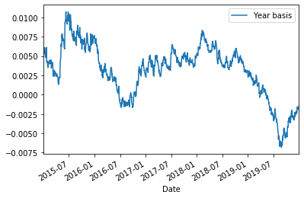We obtained a series over past five years of yearly based spot rates:

It can be appreciated a negative trend in most recent times.

Computing a geometric mean over the series of returns we got the following result which will be used as a proxy for risk free rate: .

**‣ 2) Second component of risk: market risk premium**

**What is it?**

The risk premium measures the extra return that would be demanded by investors for shifting from riskless investments to an average risk investment.

It is a function of:

1) Risk aversion of investors: the higher aversion the higher should be the premium.  
2) Risk of average risk investment.

**How did we measure it? By using historical premiums**

Indeed, focusing on historical data, is the most common approach to estimate risk premium.   
In CAPM it's computed to be the difference between average returns on stocks and average returns on risk free securities (remark: 𝛽 is assumed to be 1).

**Country risk premium, a component to be included**

Italian stock market is a mature market we have a relevant historical background and lots of trades day by day. Anyway, the country has a huge public debt which, over the years, has pushed the Country Rating toward BBB (according to S&P rating agency).

This element must be included: in fact, with respect to a no-default risk government (in our case, according to risk free rate from AAA bond) the risk premium must be enlarged by this spread; it must capture this additional component of risk.

**Our assumptions**

1) Due to the fact we have considered European AAA spot rates and Germany represents a candidate, by consistency we will compute the equity premium in German stock market and then add it the Italian country risk component.

2) The German risk premium will be computed not with an implied approach but using a time series of "Dax" index over last 5 years (weekly returns then converted into annual nominal returns).

3) We will use country default spread for Italy for 170 Basis Points .  
Then, in order to get the country risk premium we will rescale it using as scale factor volatility of Italian market (FTSE MIB in past years) over volatility in Italian bond market (as proxy a BTP with time to maturity 10 years).

4) Finally, to encapsulate coronavirus impact we will add a further risk component we have decided to differentiate in our individual forecasts.

**Analytics: step-by-step**

Again, for further information follow Python Notebook. Here will be presented main results.

We downloaded Dax daily prices over last past 5 years before Coronavirus outbreak: from 2015-01-01 to 2020-01-01.

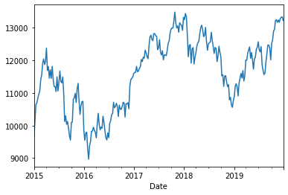This plot represents Dax price over sample period.

We deliberately excluded latest prices to not consider the drop which would have biased our result.

Due to the fact Dax was priced according to business days, after some arrangements we computed weekly log returns over time and the average weekly log return.

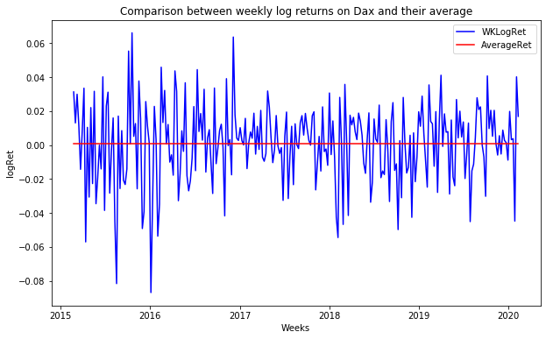

As we can see from the two plot there are outliers in our computation which reduces the average value for a bit.

Finally, in order to get German market risk-premium we converted this rate into annual and then subtracted risk free rate according to the following inverse formula: [**Notice:** here we refers to a Beta of 1] .

This yields to a proxy for German (stable) market risk premium equal to 4,54%

It remains to adjust this result with **Italian country risk premium**.

We used the following formula to retrieve a proper market risk premium for Italy: . We have used a CDS of 170 BP and computed standard deviation respectively over FTSE MIB log returns and log returns of an Italian BTP with time to maturity of 10 years (BTP May-31).

At the end we got as Country risk premium approximately 3,25%.

Adding it to the previous stable market risk premium we obtain an equity risk premium of approximately 7.79% against a 10% estimated by Damodaran (this after Covid-19, furthermore he used US T-Bonds and so a different CRP).

**‣ 3) Third component of risk: CAPM Beta**

We focused on regression Beta due to the fact A2A’s balance sheet was not enough clear in order to compute a nice enough bottom-up beta.

**‣ Regression Beta work-around**

For publicly traded firms it's straightforward to estimate returns an investor would have made on its equity over a given period. These returns can be related to a proxy for the market portfolio to get a beta approximation.

* Standard procedure: regress stock returns (A2A's performance) against market returns (FTSE MIB returns).
* Regression method: OLS linear regression of the form

The slope of regression line is the beta of the stock and measures its risk. Obviously it is an estimate which comes with a standard error.

**‣ Our decisions in estimating**

a) Length of estimation period: we have decided to use latest 10 years as length, excluding the coronavirus outbreak period.

b) Return interval: due to trade-off between bias in estimations and lack of enough observations we have decided to use weekly returns.

c) Market index proxy: we continue with FTSE MIB 40 index as proxy of portfolio market.   
  
We also have tried to regress it against a European index which includes A2A in its composition: EUROSTOXX 50.

From Investing.com we downloaded data time-series for A2A and FTSE MIB100 and in the same way we computed their log returns over the period on a weekly basis.

Then we ran a regression (again, using Python packages) getting the following results:

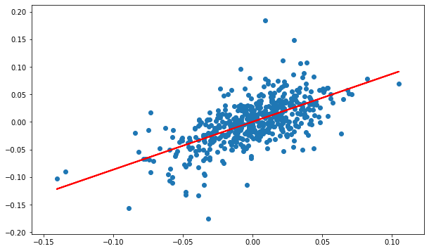

**Alpha** (intercept of the model) = 0.0003

**Beta:** regression beta = 0,868

*Regression representation of A2A (on y-axis) against Italian FTSE MIB (on x-axis)*

**Another regression: against European stock market**

We also tried to regress A2A weekly log returns against Eurostoxx 50, a good proxy for European stock market.   
Why should we use this approach? According to the assumption that we should regress against a likely set of assets we could imagine that our (marginal) investor is well diversified and active in the European stock market.

This is a good argument to use a proxy representing the average European performance: in fact, the index is composed by most appetible shares over European scene.

Here the results over the same time period of observations:

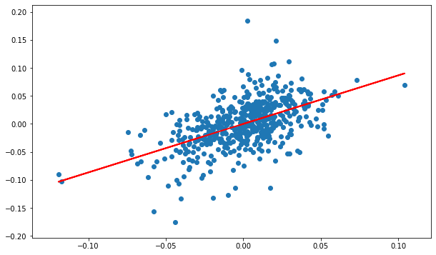

**Alpha** = -0,00007

**Regression Beta** = 0.867

*Regression representation of A2A (on y-axis) against Italian EUROSTOXX50 (on x-axis)*

It’s interesting to notice that Beta provided by Reuters is 0.89, whereas our respectively 0.868 and 0.867.

**‣ Bottom up Beta for A2A**

**How to break down betas into fundamentals**

Breaking down betas into their business, operating leverage and financial leverage components provides us with an alternative way of estimating betas.

Anyway, as said before A2A doesn’t provide a clear illustration of businesses it operates in making almost impossible for us following this approach.

**Bottom up beta possible workaround and assumptions**:

1) According to A2A disclosures, it operates in several Business Units (pag.50): most of A2A's results came from: Generation and Trading (inter-sector), Market, Waste and Networks which refers to (with large approximations) energy, water and heat distribution and waste allocation.

2) We used sector averages for unlevered betas adjusted for cash from Damodaran’s dataset. Another big assumption we made was to refer only to 4 main industries relating to utility sector where A2A operates in: Green and renewable energies, environment and waste, utilities (general and water) and gas distribution.

3) We considered 25 % of all energy from renewable production, we considered revenues values less inter-contribution and associate respectively Waste unit to waste sector and divide revenues from Market, Trading and Networks among remaining industries (25% of energy production is devoted to renewable sector).

4) Then we decided to use market debt to equity ratios (this allowed us to reduce Bottom up beta towards regression beta we have computed).



This scheme tries to resume it. Anyway, most consistent result is levered betas at 31/12 using debt to equity ratio at market value.   
We can say that due to difficulties with getting a proper business distinction and to strict assumptions we made we should follow regression beta result.

**‣Cost of equity and cost of capital computations (analytical approach)**

Once we have obtained all inputs needed to get the CAPM output we can obtain easily a proxy for cost of equity.

Furthermore, we can compute (net) cost of debt in two ways:

1) Using risk-free rate and add a given default spread provided by rating agencies (S&P) for bond ratings: in our case A2A received a BBB rating for its bond issues. Damodaran provides a spread of 1.50% to add.

2) Using latest A2A emissions, compute a weighted average of their gross internal rate of return (simply provided by A2A itself) with weights number of coupons to be paid times nominal value of outstanding bond.

The latter, preferred, provide a most updated cost of debt: in fact, A2A declared to reduce its cost of debt allowing for less expensive issues.

Finally, according to WACC we can obtain a weighted average of net cost of debt (using a marginal rate of 27.9%) and cost of equity with weights debt to capital and equity to capital.

Table below shows three possible approaches, approach number 3 which uses a regression Beta and a cost of debt in line with latest A2A debenture report is the one which will be followed in valuation (4,340 % according to Book Values).



The details about cost of debt computation in approach 3 and capital ratios are presented in the excel file (Sheet: WACC).

Ratios

In this part we want to show a brief of all ratios computed for our valuation and different techniques used. Starting from *profitability analysis*:

* ROA: the first ROA is computed dividing EBIT net of taxes by total assets. This index measures operating efficiency in generating profits from its assets.
* ROA: for the second ROA we’ve used a decomposition formula to split effects of financing from operating effects: in the numerator there is a sum of net income and interest expense net of taxes, in the denominator total assets.
* ROIC: first formula is the standard one that has at the numerator EBIT net of taxes and in the denominator the sum of book values of debt and equity.
* ROIC: in the second formula we’ve used at the denominator an average of book values (between values of equity/debt at time t and at t+1. Notice that the last value is inconsistent).
* ROIC: in the third ROIC we’ve made a product between EBIT net of taxes divided by sales and sales divided by the book value of capital.   
  That is to say: pre-tax operating margin and capital turnover ratio. A firm can arrive at a high ROIC by either increasing its profit margin or efficiently using its capital to increase sales.
* ROE: the first one is computed summing ROIC to the product between debt to equity ratio and the ROIC minus interest rate net of taxes.
* ROE: the second is computed dividing net income by the book value of common equity.
* ROE: the last value is computed as before, but with an average of book value of common equity. As before the last value is inconsistent because based on an average between t and t+1.

Ratios for liquidity analysis:

* Current ratio: obtained dividing the current asset by current liabilities, in the first row we used the total current assent;in the second we’ve netted from current assets current financial liabilities and current tax assets.
* Quick ratio: obtained by dividing the sum of cash and marketable securities by current liabilities.
* Acid test: similar to quick ratio, is given by subtracting from the current asset the inventories and dividing the obtained value by current liabilities.

For *working capital analysis* we have used:

* DSO: obtained dividing the current amount of trade recivables multiplied by 365, by current year sales.
* DIO: obtained dividing the current amount of inventory multiplied by 365, by current year expenses for raw materials.
* DPO: obtained dividing the current amount of trade paylables multiplied by 365, by operational expenses.
* DPO (raw materials): given dividing the current amount of trade paylables multiplied by 365, by current expenses for raw materials.
* Cash conversion cycle: DSO + DIO – DPO
* Cash conversion cycle: DSO + DIO – DPO[raw]

For financing analysis, we’ve selected four different ratios:

* Interest coverage ratio: given dividing EBIT by interest expense.  
  This ratio measures the capacity of the firm to meet interest payments but not whether it can pay back the principal of the outstanding debt.
* Debt to capital ratio: we’ve computed in two different ways. The first one dividing debt by the sum of debt and equity; the second one dividing debt by net invested capital.
* Debt to equity ratio: obtained simply dividing debt by equity.
* Reinvestment rate: given by the sum of net capital expenditures and changes in working divided by EBIT net of taxes

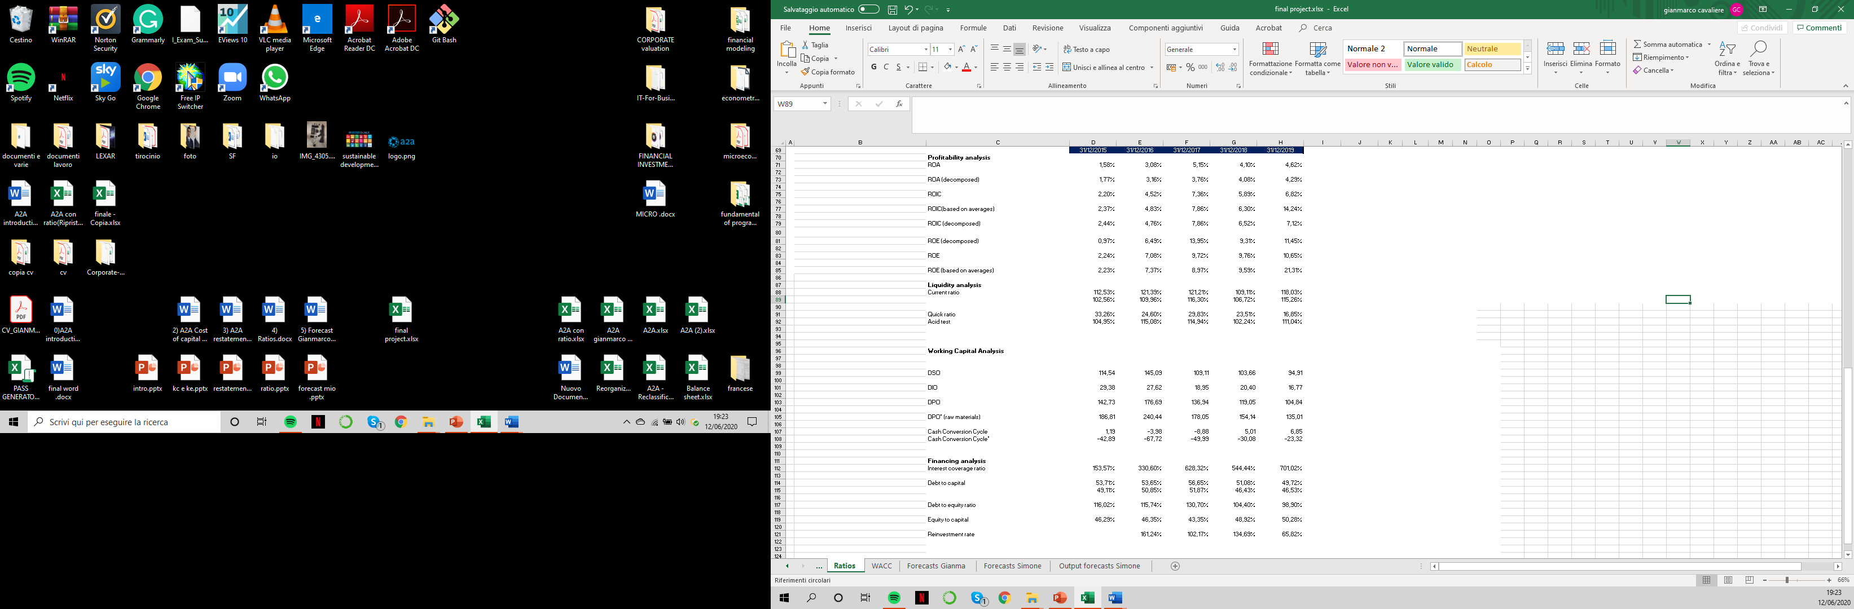

**Firm valuation model - The cost of capital approach**

**Gianmarco Cavaliere’s forecasts and valuation**.

The goal of this approach is to obtain the value of a firm today by discounting the free cash flow to the firm (FCFF) at the weighted average cost of capital (WACC), so it values the firm rather than the equity. This model suggests two different periods of growth: one of high growth and the other one, called steady-state, with a lower growth rate that the firm could maintain for a long period. One of the biggest advantages of this approach is that it captures the tax benefit of borrowing and the bankruptcy cost, and another one is that cash flow relating to debt does not have to be considered explicitly. The only pieces of information required are debt ratios and interest rate to estimate the cost of capital. The formula used to compute the value of a firm in this one:

Value of firm =

For a good explanation of the obtained values, hereafter there are all the assumption made during the computation:

* Since we have used a different way to compute FCFF and FCFE, I've must modified a little Damodaran's model. I'm going to consider, in addition to tax in EBIT, also the tax shield generated by financial items and changes in provision, employee benefit, tax asset and other minor to forecast consistently every value
* As we’ve seen previously, we computed WACC in three different approaches and I chose the third one for my valuation because we used a regression levered beta near to one and an average cost of debt of 2,18% (higher than others cost of debt used). Also, I used a different WACC (computed with beta equal to one) as a terminal cost of capital to obtain the terminal value at the end of the high growth period. So, i used a WACC for high growth period = to 4,70% (cost of equity = 7,08%) and another WACC for the steady-state = to 5,87% (cost of equity = 10,47%)
* An expected growth rate for EBIT = 8,26%, computed by dividing ROIC obtained in 2019 for the Reinvestment Rate = 115,98% (average of historical period). This growth rate is higher than that one stated by the management in the last strategic plan, maybe due to fact to make the expectation lower with the intention of beating them.
* For the growth rate in the steady-state, I wanted to use a fundamental growth rate extracted by Damodaran's dataset, which results equal to 7,68%, it’s a European average of growth rate for the utility sector. This value could seem really high to sustain for a long period of time, but I think, based on what management declared, that A2A might sustain it; first of all, because this company is green-oriented so it’s aiming to sustainability in term of production of energy but also with innovative projects like “Smart City”.

To forecast all items needed I've made some assumption about each one:

* Revenues: to forecast them first I've multiplied the last value available for the last recorded growth rate, and I assumed it constant for all the forecast period.
* EBIT: I considered EBIT always net of taxes (with constant tax rate = 27,9%) and to forecast future value I've computed a growth rate using the last ROIC available and an average of reinvestment rates.
* CAPEX: assuming it as a percentage of Revenues, so I've computed an average between percentages in historical data, and use it, constant, to forecast values in future period
* D&A: assuming it as a percentage of CAPEX, and to forecast its values I used the same methodology for CAPEX
* Changes in Provision: assuming a constant positive changes because their are unpredictable.
* Changes in Employees Benefit: being this asset not too volatile I'm going to use as forecast values the same value given by the average of changes
* Changes in TAX asset: I decide to take the last value of that asset constant for my forecast
* Other minor: as previous items I computed an average of changes during years and use it to forecast values for the future period
* Changes in NWC: I've assumed that they are a percentage of Revenues, after that I've made an average, and i used this value for each year in the forecast period

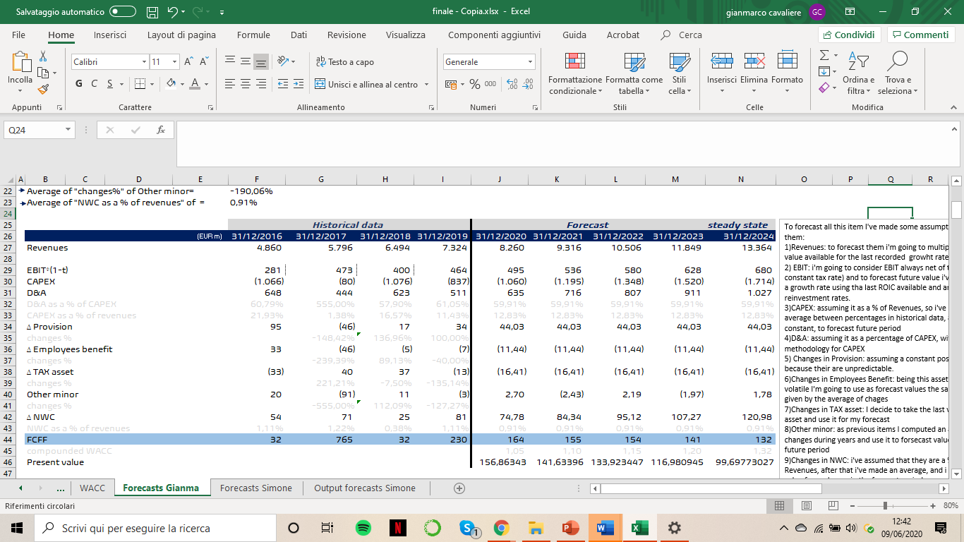

To obtain the value of EPS, as we can see below, first of all i computed the terminal value taking the last EBIT (steady-state) and multiplying it for stable growth rate, tax rate and reinvestment rate. After i divided the value obtained by the difference between stable WACC and stable growth rate. To get the discounted value i simply discounted it at the stable WACC. Once I've obtained this value, i summed up that one with the forecasted and discounted free cash flows. This sum is the terminal value, also called the enterprise value. From it to equity value we have to add “cash and marketable securities”, “value of minority holdings” and “value of inutilized asets”, and substact out non-equity claims on the company.

Doing that, I arrived to the “value of equity in common stock” and dividing it for the outstanding shares (3109,18) i obtained the value of a single share.

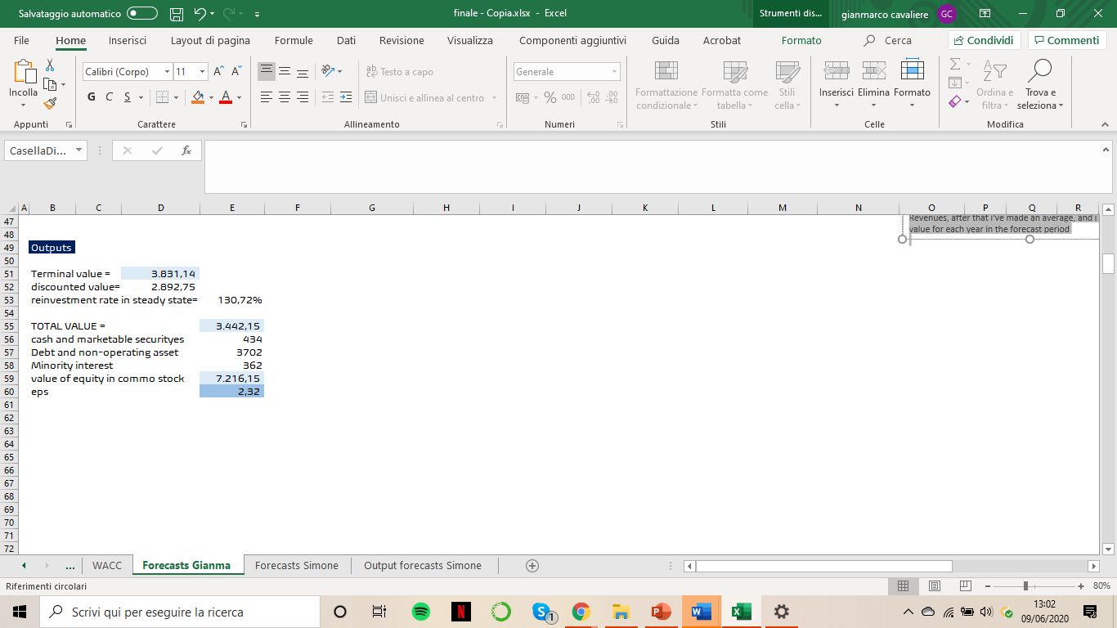

Nowadays the stock is trading at about 1,35 euros per share, making it heavily undervalued. But a clarification is worth to be done: this is the actual value of the company, which recorded an huge decrease (more or less 60 %) due to COVID-19 crisis, that it had influenced the greatest majority, if not every, sector.

Before this period, the share was trading at about 1,8 euros per share and A2A stock price was characterized by a constant positive trend from 2012 up to now. So If we are assuming a stock price pre-crisis, the difference between the value obtained from the approach used and the traded price is lower than the difference with the actual value, making the value obtained more acceptable.